**A fond farewell to our friend, Silents Under the Stars projectionist, and Hart/Film historian, David Shepard**

For our friends who used to come to Silents Under the Stars, back when we used film and you could hear the projector in the background clicking away – we miss it too! And we miss our friend who brought the projector, the film, his immense historical knowledge, and his wry sense of humor, David Shepard.

We're please to reprint this article, by Leonard Maltin, film historian and Friend of Hart Park, with his kind permission. From Mr. Maltin's website LeonardMaltin.com:

# **ADIEU TO DAVID SHEPARD**

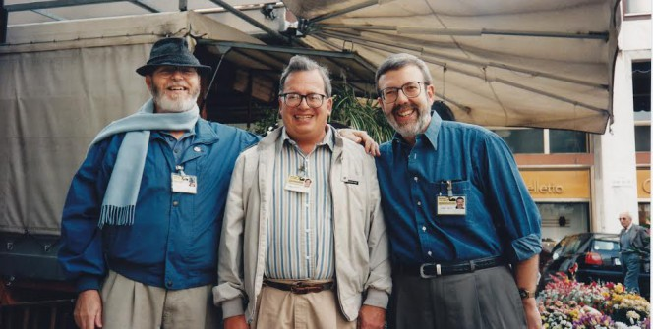

[*Three film-buff friends on the loose in Italy, 1995: Russell Merritt, David Shepard and me at the annual silent film festival in Pordenone, Le Giornate del Cinema Muto.*](http://leonardmaltin.com/wp-content/uploads/2017/02/unnamed-6.jpg)

I was 16 years old when I first met David Shepard, and before our first conversation was over he offered to loan me a 16mm print to screen for my high school Motion Picture Club. It was a typically generous gesture for a man who devoted his life to saving films and showing them to appreciative audiences. If you’ve seen a superior print of a film by Chaplin or Keaton, Griffith or Murnau, chances are David had a hand in restoring it.

We both grew up in New Jersey and had the same mentor, an unforgettable man named John Griggs. He was an Actor by trade and disposition, but his hobby was collecting films. He also ran a part-time business called Griggs Moviedrome, selling 8mm and 16mm copies of vintage films in the public domain. His greatest joy was introducing young people to the great silent classics he loved so much. He helped to set David Shepard on his lifelong path and several years later took me under his wing. (He also sponsored a young actor named Peter Coyote for membership in the Players Club in Manhattan.)

David went on to do great things. He was hired as a curator by the newly-minted American Film Institute in the late 1960s and reverse-engineered his first major donation. By visiting film storage facilities in Fort Lee, New Jersey, he learned that Paramount Pictures had original 35mm nitrate negatives of 200 silent features on deposit. Then he approached Paramount and made them an offer they couldn’t refuse: if they gave those films to the AFI collection at the Library of Congress, they would no longer have to pay storage fees and would receive a tax deduction, to boot. It was a win-win, the first of many that David facilitated in his long career. (The story had a bittersweet postscript: by the time the Paramount collection was transferred, twelve of those two hundred movies had decomposed.)

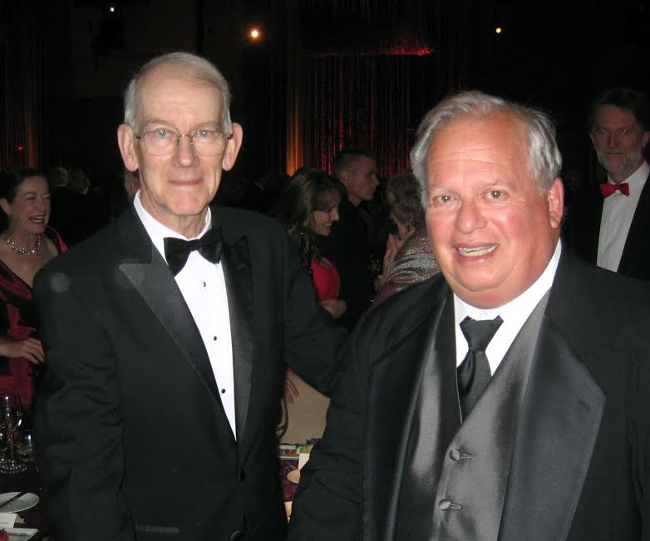

*Two exceptional people: Kevin Brownlow and David Shepard, on the night Kevin received his honorary Oscar in 2010*

How many people would pick up stakes and move to Davenport, Iowa to pursue a job? David did, when Kent D. Eastin, the founder of Blackhawk Films, offered him a position there. Working for the country’s leading distributor of movies for the collector market, David brokered a number of great deals, including home-movie rights to the Fox Movietone newsreel library. He uncovered countless gems, including the long-lost Robert Benchley short The Treasurer’s Report. Unfortunately, the rights to this milestone comedy lecture belonged to Raymond Rohauer, so he never got to release it… but he did manage to make one or two 16mm prints before sending the original negative to Rohauer, his longtime bête noir. He also created an uproariously funny edition of Thomas Edison’s The Kiss that poked fun at Rohauer and his mania for self-promotion.

In his never-ending search for the best possible copies of Charlie Chaplin’s Mutual comedies, he purchased an entire library of cartoons, shorts, and B movies he didn’t particularly crave–just to get his hands on the 1930s Van Beuren reissues of the Chaplin comedies.

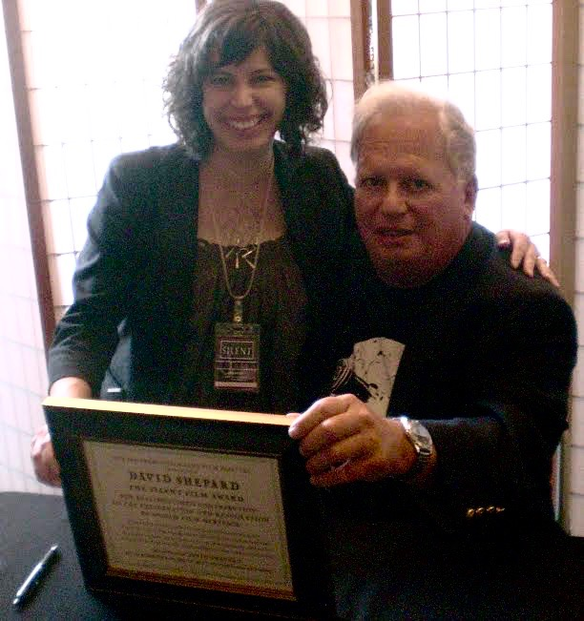

*David accepts another award from Stacey Wisnia at the San Francisco Silent Film Festival in 2008*

Following his stint in Davenport, David became affiliated with the Directors Guild of America in Los Angeles and did more favors for posterity through his oral history program and other activities. Do you remember those behind-the-scenes featurettes about movies of the 1960s and 70s that used to turn up as filler on local television? David arranged to acquire not only the finished shorts but the raw footage as well for the DGA. He also taught at USC and UCLA here in Los Angeles; one of his teaching assistants was filmmaker Alexander Payne, who has remained a loyal friend.

Later on, he licensed the Blackhawk Films name and remaining assets and launched his own company, Film Preservation Associates. I visited his headquarters in Panorama City one afternoon where he proudly showed off his equipment–including an old-fashioned printing press that he used (in those pre-computer days) to re-create title cards with the appropriate fonts, lining up words and sentences with lead type as a newspaper publisher would have done a hundred years ago.

The advent of home video gave David new opportunities to pursue and finance a variety of film preservation projects, too numerous to mention. He found kindred spirits in Serge Bromberg at Lobster Films in France and Jeff Masino at Flicker Alley in L.A.

David was such a major presence in film preservation that it’s difficult to think of that world without him. I’ll miss seeing him at the San Francisco Silent Film Festival this spring, and have been told that the event will be dedicated to him, which is fitting and proper.

As to the man behind all this extraordinary work, David was always good company but not the easiest person to know. Our mutual friend Dick Bann has called him a complex person, a man of contradictions, and that rings true to me. He wound up living in near-isolation in a log cabin in Hat Creek, California, surrounded by his beloved rescue dogs. They were with him, along with family members, when he died on Tuesday at the age of 76.

I will never forget his many kindnesses or his unselfish nature. It was the films that mattered most to him. Cinema students, scholars, and enthusiasts will be in his debt forever.